BANK DATABASE
EXTRA QUERRIES
TEJAS BHARADWAJ

-- customers with accounts in all branches in a specific city
select bc.customer_name, b.branch_name
from bankcustomer bc, branch b
where bc.customer_city=b.branch_city and b.branch_name =All(select branch_name from branch where branch_city="Delhi");
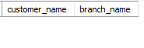
-- all customers who have account and loan at the bangalore branch

select d.customer_name
from depositer d, bankaccount bc, loan l, branch b
where d.acc_no=bc.acc_no and bc.branch_name=b.branch_name and b.branch_name=l.branch_name and b.branch_city="Bangalore";
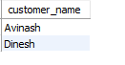

-- all branches that have grater assets than every branch in bangalore

select branch_name
from branch
where assets>All(select assets from branch where branch_city="Bangalore");
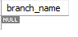

-- delete all accounts where city is delhi
delete from bankaccount b
where b.branch_name IN (select branch_name from branch where branch_city="Delhi");

select *from bankaccount;
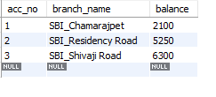

-- update balance of all accounts be 5%

update bankaccount
set balance=balance+balance*0.05;
